Day Camp is for Cub Scouts entering 1st through 5th grade next school year.  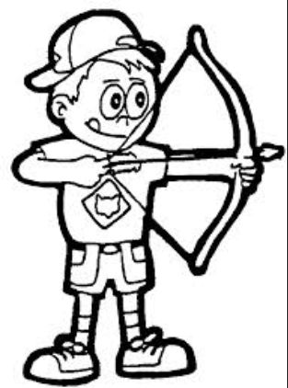  “Day Camp is the most fun I had all summer. I even shot a bullseye!” Cameron, Pack 72 | About Us  Boy Scouts of America  The Boy Scouts of America is one of the nation's largest and most prominent values-based youth development organizations. The BSA provides a program for young people that builds character, trains them in the responsibilities of participating citizenship, and develops personal fitness. www.scouting.org  XYZ District  The XYZ District serves Scouting units located in this area.  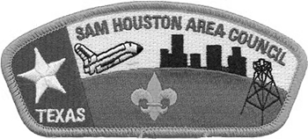  Sam Houston Area Council  The Sam Houston Area Council, BSA, serves nearly 60,000 youth in 16 counties southeast Texas area through dedicated service and leadership of nearly 20,000 adult volunteers. Scouting is completely funded by the generosity of our local communities.  Sam Houston Area Council  Cockrell Scout Center  2225 N Loop W  Houston, Texas 77008  (713) 659-8111  www.samhoustonbsa.org  There are 25 camps around the council. Find additional locations at www.shac.org/day-camp. | XYZ District  Day Camp  June 1-5, 2017  Time  Location  www.district.shac.org/day-camp
Register for Day Camp between February 1 and May 6, 2017  district.shac.org/day-camp  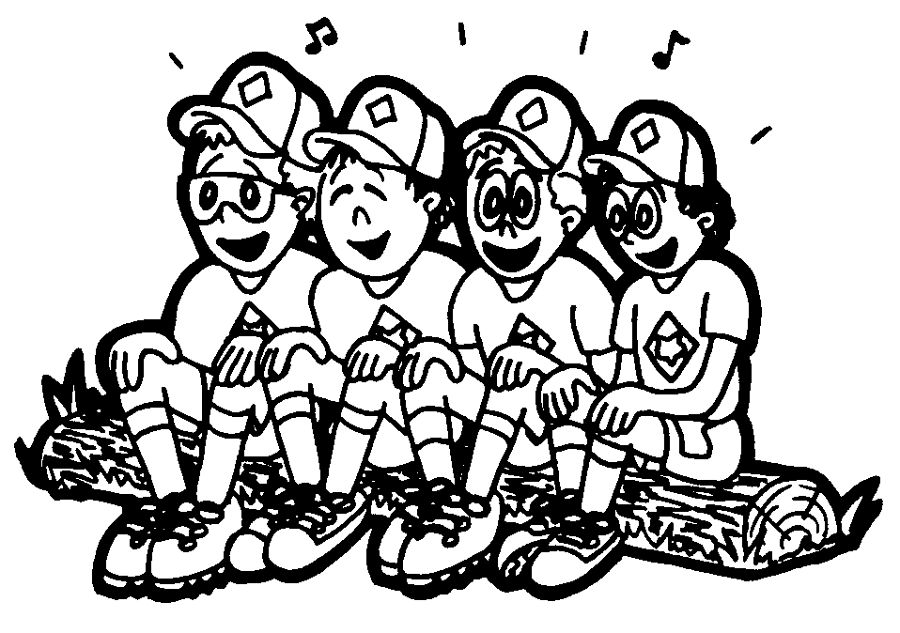  A safari adventure awaits. Going to camp is a wonderful part of the Cub Scouting experience, and offers unforgettable experiences and memories. Participants will receive a t-shirt and patch.  Adult Volunteers. Day camps are a 100 percent volunteer effort. To ensure a successful and safe day camp program, volunteers are needed to assist the staff and guide the Cub Scouts through each day’s activities. Packs must provide a minimum of one adult volunteer each day for every four boys attending each camp from your pack. | Advancements  Scouts will be working towards achieving parts of the following advancements.  Tigers (1st grade)  - Curiosity, Intrigue, and  Magical Mysteries  - Good Knights  - Floats and Boats  - Stories in Shapes  - Tiger Theater  Wolf (2nd grade)  - Air of the Wolf  - Code of the Wolf  - Finding Your Way  Bear (3rd grade)  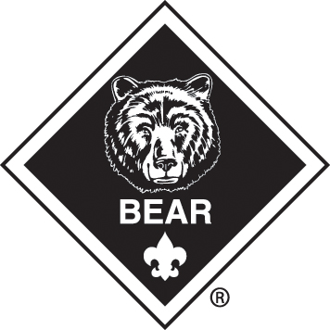  - Bear Claws  - Baloo the Builder  - Make It Move  - Super Science  Webelos (4th grade)  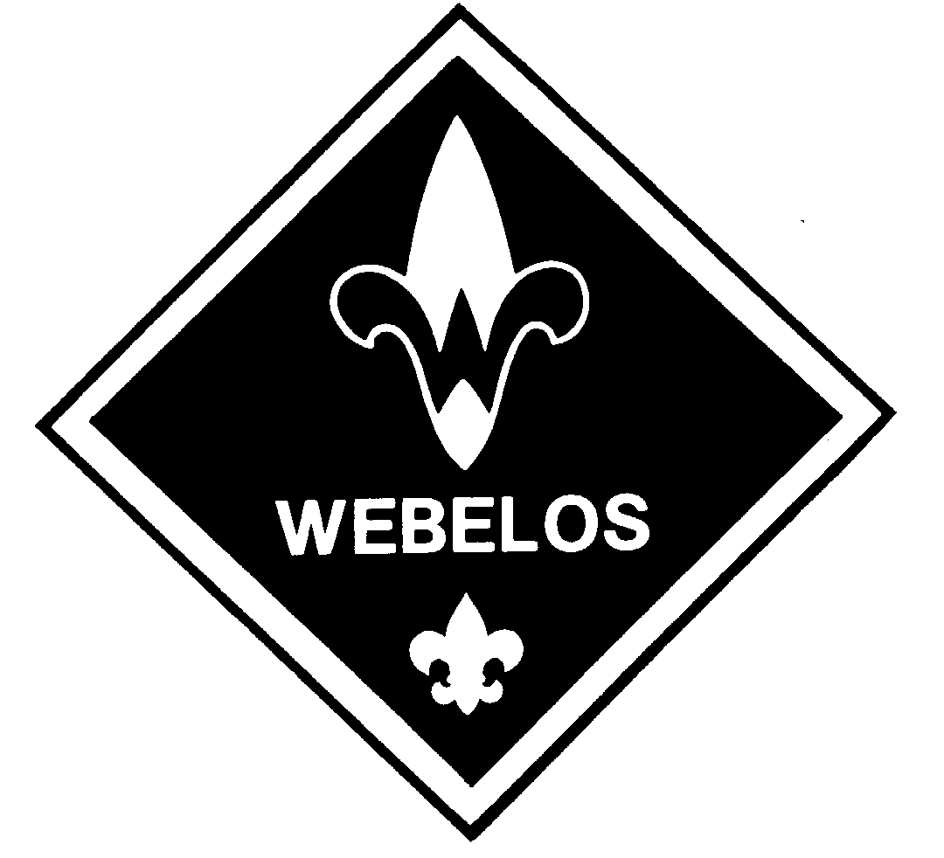  - First Responder  - Art Explosion  - Build It  - Engineer  Webelos (5th grade)  - Introduction to Boy Scouting skills (e.g., knots, first aid, orienteering, camping | Scouts will learn outdoor skills, shoot archery and BB guns, enjoy STEM activities, play sports, earn advancements, make crafts, and more.

